BEENEUM MUIGAI
Task 1: Understanding the business problem
The healthcare organization needs a clearer view of encounter demand, recorded claim costs, payer coverage and procedure utilization. I will investigate how encounter volumes and financial measures differ over time, across encounter classes and by payer, and identify frequently recorded and high-cost procedures.
This matters because operations and finance teams need evidence to prioritize workload reviews, investigate coverage gaps and understand where recorded costs are concentrated. The intended users are hospital operations managers, finance managers and analysts.
The dashboard presented will support decisions about further capacity investigation, coverage data review and procedure-cost monitoring.
The evidence is limited to the records supplied. It does not establish staffing demand, actual payments collected, profit, bed occupancy, clinical appropriateness or causes of cost differences. The data represents one organization, covers unequal time periods, and includes unusual encounter durations. Findings will be presented as descriptive historical analysis.
In the analysis, we shall be using “recorded claim costs,” not “revenue” or “profit.”

Task 2: Inspecting the datasets
There are five operational CSV datasets, plus one metadata CSV, two SQL resources and one assignment PDF. The dictionary is not another patient or encounter table. Its five blank Field entries are table-level description rows, not missing clinical data.

Task 3: Defining measurable success criteria
- After loading, every operational table has the same row count as its source CSV; no undocumented exclusions occur.
- Encounter keys and dimension keys are unique, required relationship keys have no unresolved orphan records, and procedure patients agree with their parent encounters.
- Excel and SQL agree on encounter count and zero-coverage count exactly, and monetary totals within 0.01 in source currency units.
- At least three filtered scenarios reconcile between SQL and Excel, including a year, an encounter class and a payer; all connected visuals respond as documented.
- All eight Track A questions have a defined metric, reproducible calculation, interpretation and limitation. The workbook includes the five required analytical areas and at least five meaningful KPIs.
- No patient names, street addresses, full dates of birth or patient identifiers appear in public screenshots or repository exports.

TRACK A QUESTIONS:
Question 1: How have encounter volumes changed over time?
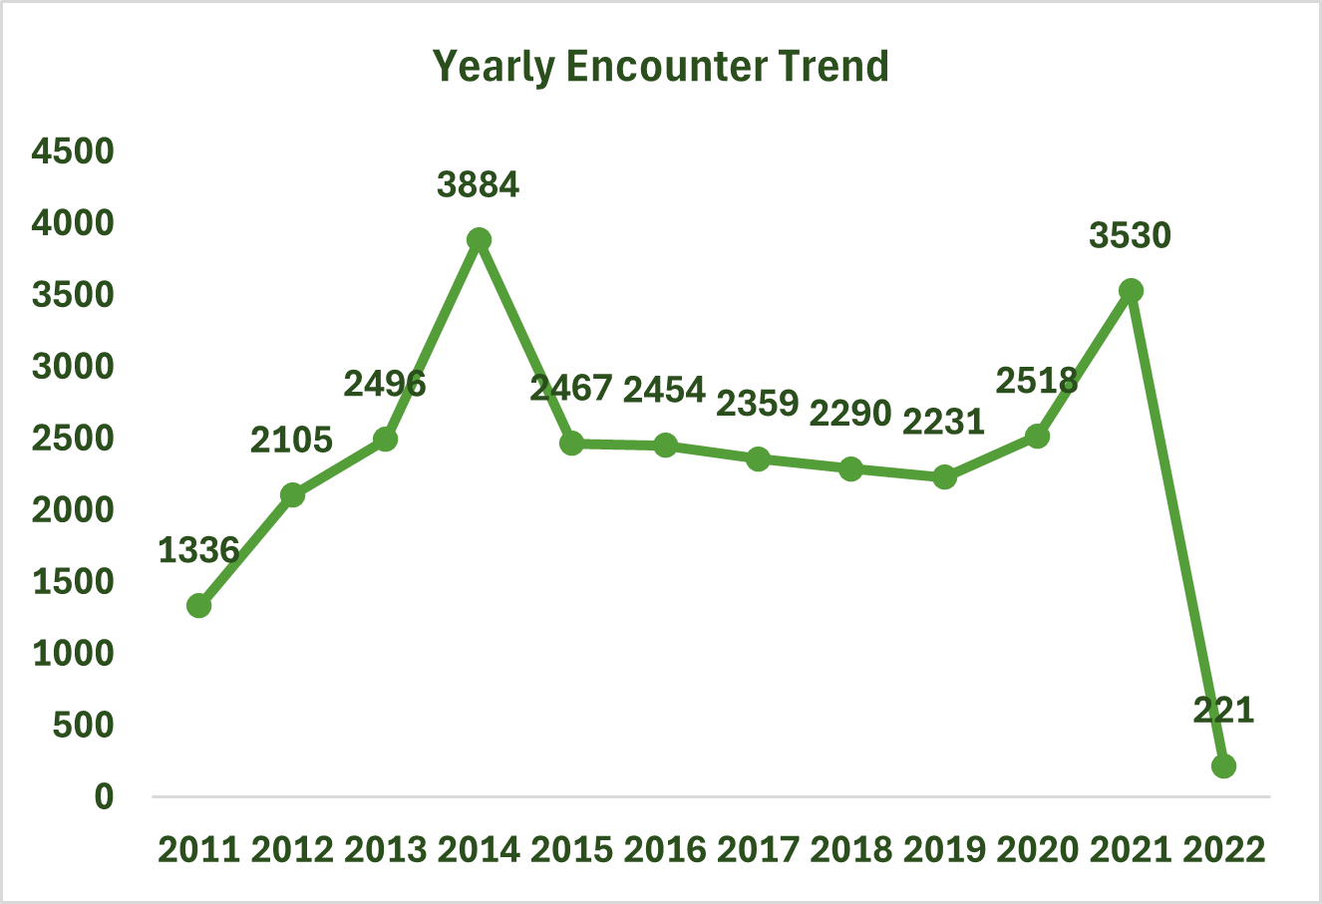

2014 recorded the highest annual volume, with 3,885 encounters.
2021 recorded 3,530 encounters, compared with 2,519 in 2020.
2022 contained only 220 encounters through February 5, making it an incomplete year.

Question 2: Which encounter classes account for the largest proportion of recorded encounters?
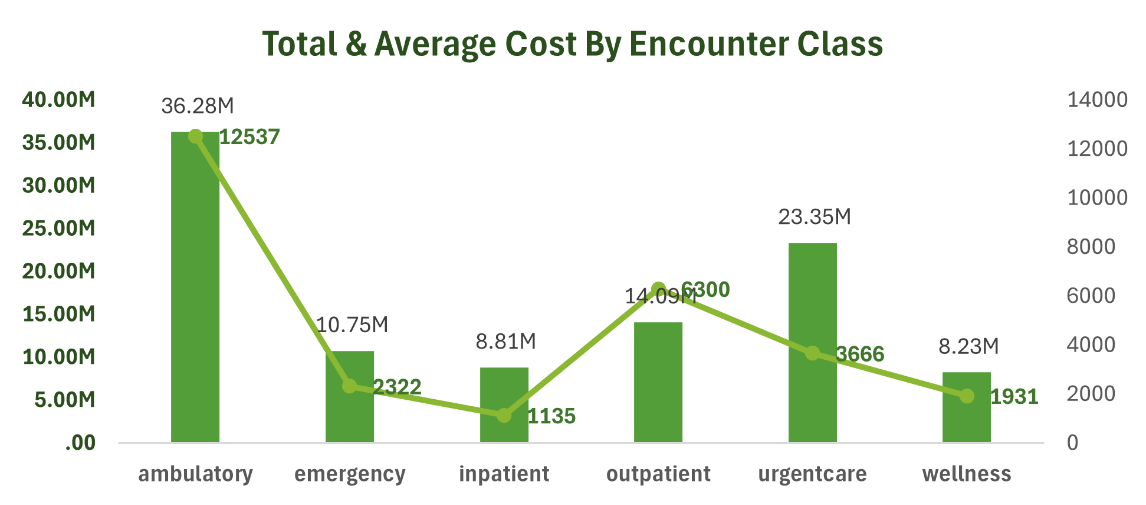

Encounter class | Encounters
Ambulatory | 12,537
Outpatient | 6,300
Urgent care | 3,666
Emergency | 2,322
Wellness | 1,931
Inpatient | 1,135

Question 3: How do total claim costs vary across encounter classes?
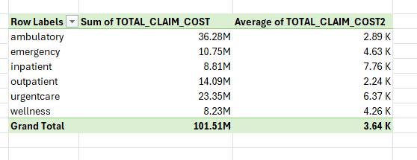
Ambulatory encounters account for the largest total claim cost, while inpatient encounters have the highest average claim cost.
Question 4: Which descriptions occur most frequently?
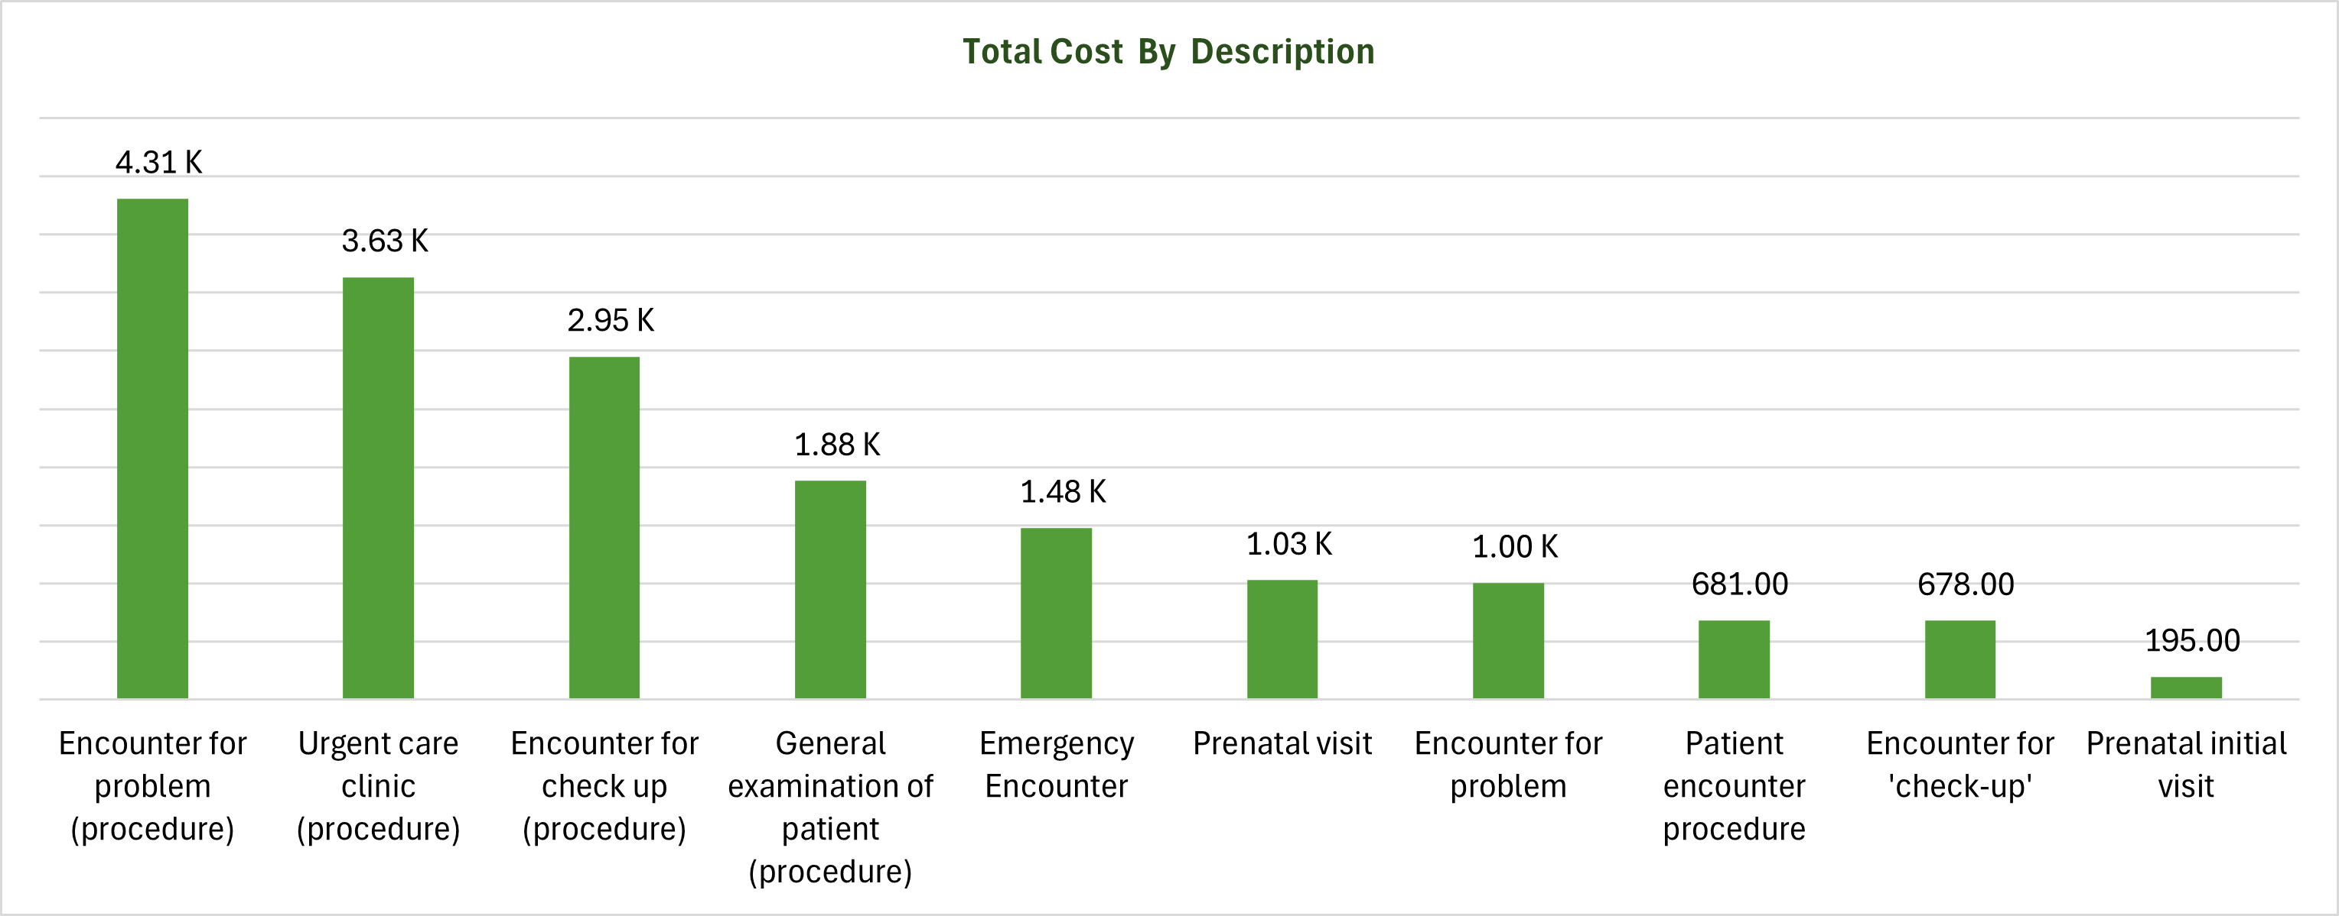

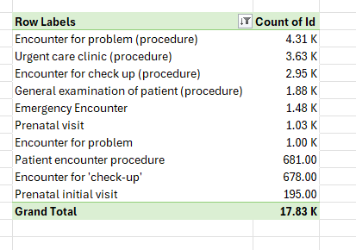

VALIDATING THE DASHBOARD
- I made sure the slicers are interactive
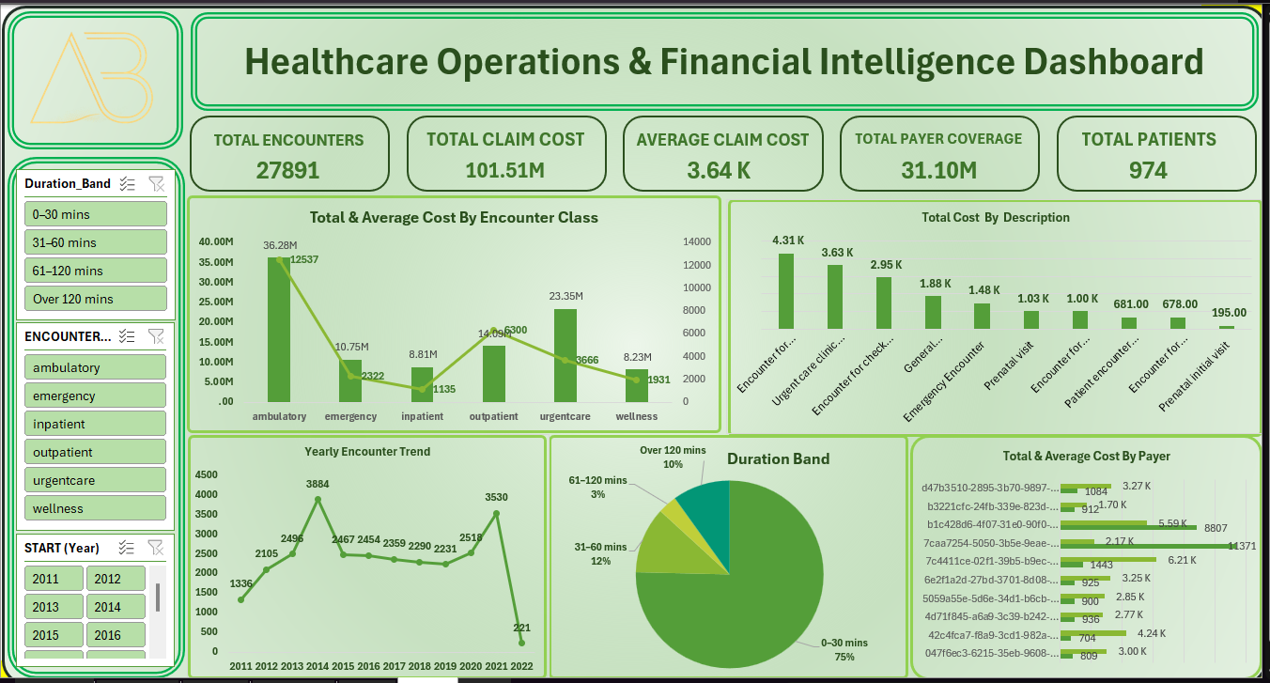
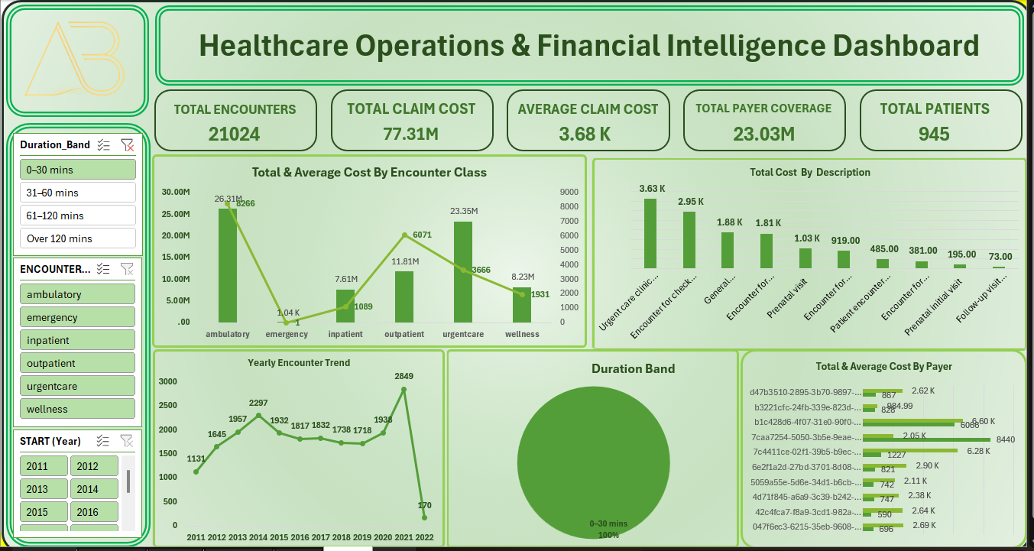
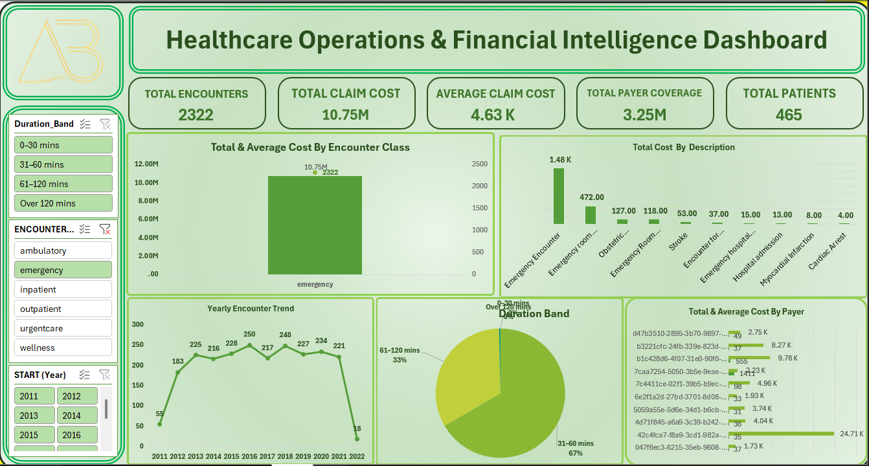

- Verification of Calculation.
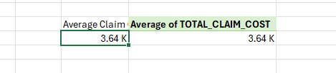
Average claim cost is equal with calculated field as the pivot table

Business recommendations
Here are four recommendations based on the findings from the analysis.
Recommendation 1: Review high-cost encounter categories
Finding: Ambulatory encounters recorded the highest total claim cost, approximately $36.28 million. Inpatient encounters had the highest average claim cost, approximately $7,761.35.
Proposed action: Hospital management should investigate the cost drivers behind high-volume ambulatory services and high-cost inpatient encounters.
Intended benefit: Identify opportunities to improve resource allocation and manage healthcare expenditure.
Limitation: The analysis does not establish whether higher costs are caused by treatment complexity, resource consumption or differences in patient needs.
Recommendation 2: Improve payer coverage monitoring
Finding: Recorded payer coverage was approximately $31.10 million against total claim costs of $101.51 million, representing 30.63% coverage.
Proposed action: Introduce regular monitoring of payer coverage records and investigate encounters with missing or zero recorded coverage.
Intended benefit: Improve financial visibility, identify potential documentation gaps and support better revenue-cycle management.
Limitation: Zero recorded coverage does not necessarily mean that the patient or hospital received no payment. Additional payment and reimbursement records are required.
Recommendation 3: Monitor encounter growth and resource demand
Finding: Annual encounter volumes increased from 2,519 in 2020 to 3,530 in 2021, representing approximately 40.13% growth.
Proposed action: Hospital management should review staffing, equipment and service capacity against changes in encounter volumes.
Intended benefit: Support resource planning and reduce the risk of capacity constraints as demand increases.
Limitation: Encounter volume alone does not establish whether additional resources are required. Staffing levels, facility capacity and patient complexity should also be considered.
Recommendation 4: Strengthen financial oversight across organizations
Finding: The organization comparison shows differences in total recorded claim costs.
Proposed action: Management should investigate organizations with comparatively high claim costs and review the factors contributing to those differences.
Intended benefit: Improve cost monitoring, identify unusual spending patterns and support more informed financial decisions.
Limitation: Differences in claim costs may reflect differences in encounter volumes, service types and patient populations. A fair comparison should account for these factors.

